**SHRI RAMSWAROOP MEMORIAL COLLEGE OF ENGINEERING AND MANAGEMENT DEPARTMENT OF COMPUTER SCIENCE AND ENGINEERING**

**FARMING WEB ASSISTANCE SERVICES**

**PROJECT MEMBER**

**Aviral Jaiswal (2101220100035)**

**Himanshu Singh Chauhan(2101220100054)**

**PROJECT GUIDE:**

**ER. Abhishek Dubey**

**PROPOSED METHODOLOGY**

The Farming Web Assisting Services project

uses the Iterative Waterfall model, combining the structured phases of traditional Waterfall with the flexibility of iterative feedback. This ensures each development stage builds clearly on the last while allowing improvements based on user needs. The approach delivers a robust, adaptable, and user-focused farming service system.

**RESULT ANALYSIS**



* 1. User Authentication and Profiles

Login: Secure sign-up via email, phone, or social accounts.

Profiles: Farmers enter details like location and crops for personalized content.

* 1. Farming Information and Resources

Crop Guides: Info on planting, soil, and water needs by crop and region.

Weather: Real-time forecasts and alerts for better planning.

News: Updates on farming trends, schemes, and policies.

**INTRODUCTION**

**SCREENSHOTS**

**CONCLUSION**

India’s agriculture sector supports about 55% of

the population but faces issues like poor

marketing

Farming

and

middlemen

Assistance

Web

exploitation. The

Application helps

farmers sell directly to suppliers, access market

data, and manage resources efficiently. It connects farmers with experts and ensures secure, mobile-friendly access, promoting sustainable and profitable farming.

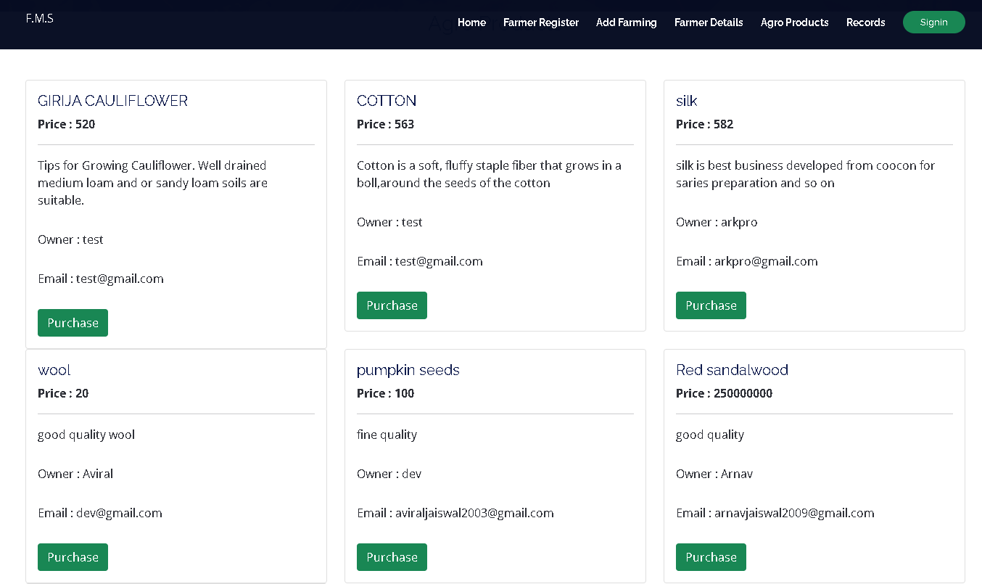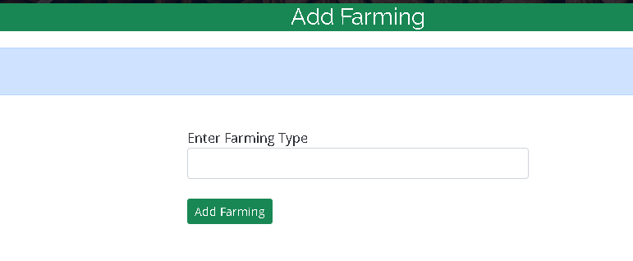

The project delivers a user-friendly digital platform that empowers farmers by connecting them directly with buyers and providing real-time market insights. It ensures efficient, adaptable, and sustainable farming support through a robust and flexible development approach. Collaborations with research institutions and government bodies further enhance the application’s effectiveness, contributing to a more sustainable and efficient agricultural system.

**OBJECTIVE**

The project aims to develop a digital platform to support farmers, agricultural workers, and stakeholders by addressing key challenges in the farming sector. It connects farmers directly with buyers, reduces costs through an economical, user-friendly GUI, and offers smart suggestions to simplify communication without needing full translations.

**LIMITATIONS**

* Requires stable internet, which may be lacking in rural areas
* Some users may face difficulty due to low digital literacy
* Real-time data may occasionally be outdated or inaccurate
* Limited language support can affect accessibility
* Older devices may not fully support all features

**FLOW CHART**

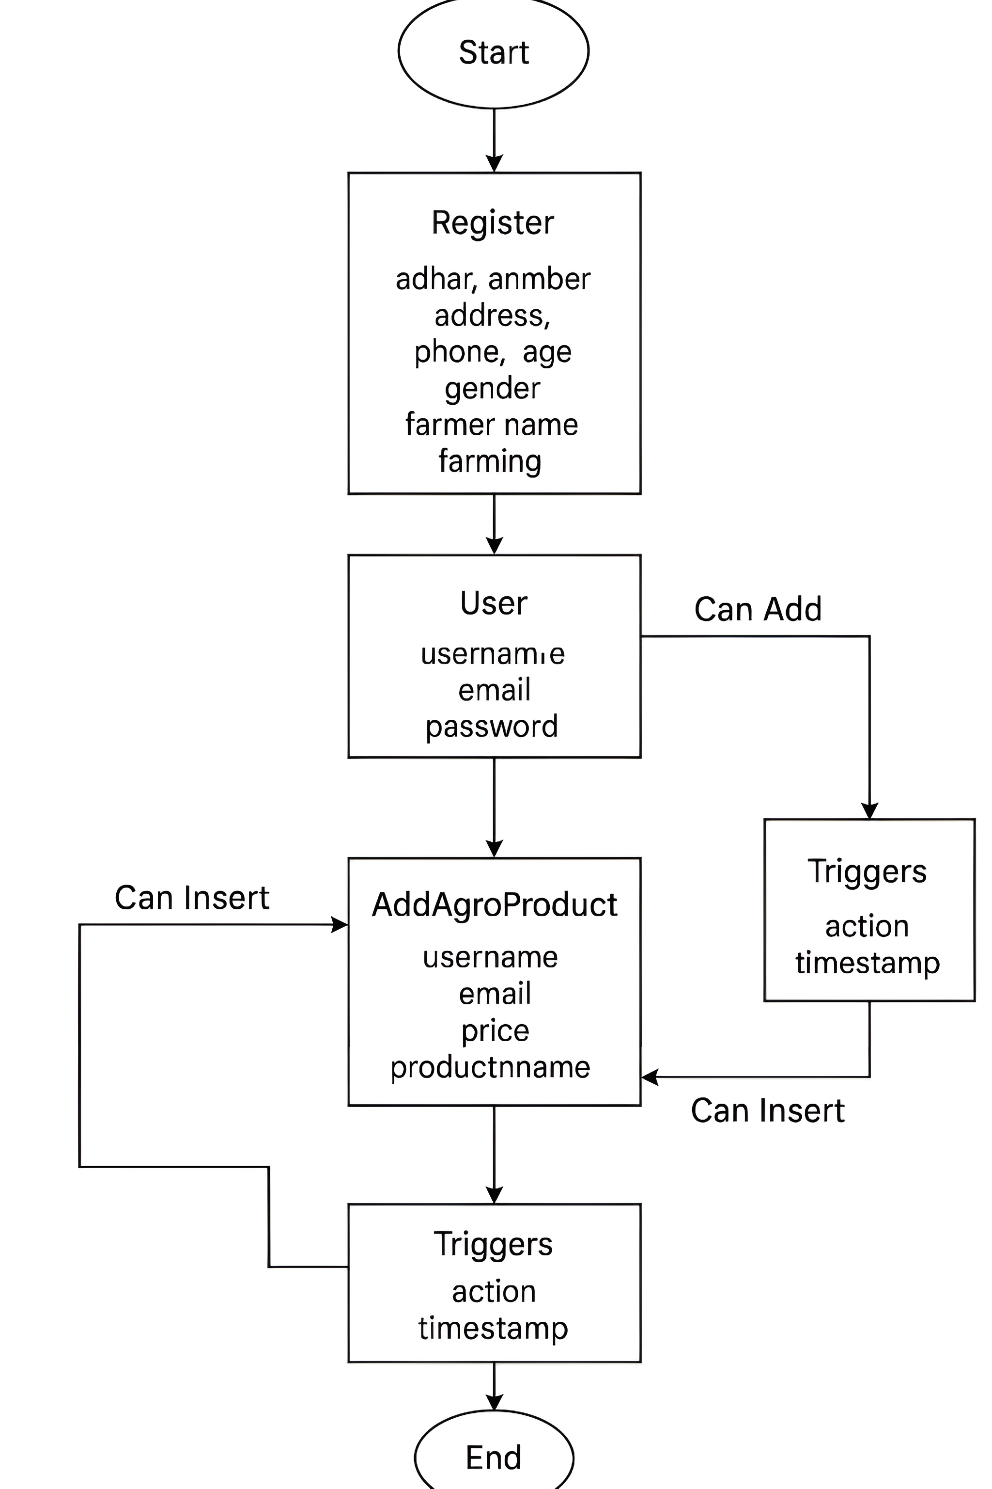

**FUTURE SCOPE**

In conclusion, IoT, blockchain, and AI together can significantly transform agriculture by improving efficiency, traceability, and smart decision-making. IoT enables real-time monitoring of crops and soil, while blockchain ensures transparent and secure supply chains. AI helps in predicting yields, detecting pests, and optimizing resources. Additionally, partnerships with institutions and tech providers increase trust, support, and reach. Together, these elements pave the way for smarter and more sustainable farming.

**MODULE DESCRIPTION**

**REFERENCES**

1. T. J. Pettit et al. (2010) proposed a conceptual framework to enhance supply chain resilience.
2. ISO 28000-2007 provides guidelines for security management in supply chains.
3. Md. Razu Ahmed et al. (2020) explored the use of blockchain in electronic voting systems.
4. Srisruthi et al. (2016) focused on sustainable agriculture using eco-friendly sensor technologies.
5. Shankar M. Patil et al. (2019) developed an Android app to assist farmers with various agricultural tasks.
6. Abishek A.G. et al. (2016) highlighted the role of web and mobile technologies in agriculture marketing.
7. Shital Chaudhari et al. (2018) presented a smart farming approach through an Android-based application for modern agriculture practices.

**ADVANTAGES**

* Farmers have access to a wealth of information, enabling informed decisions for increased productivity and profitability.
* Farmers can connect with potential buyers, expanding market reach and improving sales opportunities, leading to better income and market stability.
* Farmers can advertise their crops to showcase products directly to suppliers.
* Farmers can sell their products directly to suppliers, eliminating middlemen.